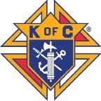
The Sentinel
January 2019– Volume 26 – Issue 1 All Saint’s Council #4240 – Menomonee Falls, WI
GRAND KNIGHTS MESSAGE:
Dear Brother Knights

January is the time of the year when March for Life is in full swing. March for Life are events that rally people to show support for building a culture of life and make a stand against abortion. They need our support. There are two big marches, one in Washington DC(Jan. 18) and another in Chicago(Jan. 13). They are both great events. Please support them.

I would like to thank everyone who helped at Corporate Christmas, Ushering at Holy Hill, and Caroling this month. They were very successful. Your help is always appreciated. Some future events in January and February are: March for Life in Chicago(Jan.13), March for Life in Washington DC(Jan.18), and Superbowl Party(Feb. 3)

May the joy of God be with you and bless you forever.

John Schleicher
Grand Knight

Knight of the Month: Paul Wettstein

Brother Paul has been a Corporate Board and Officer for a few years. He does it to keep our council moving forward. Paul waxes our floors in the clubhouse and they look very nice. He volunteers for almost every event. Thank you for everything, Paul.

Family of the Month: Thomas Ullrich & Family

Thomas has done a lot for the Chapter over the years. He and his family have made ushering at the Christmas midnight mass at Holy Hill their tradition for over a decade now. His wife, Luci, and daughter, Anna have also been very involved. Lucie organizes the decorating of our Clubhouse and it always looks really nice. In addition, Luci and Anna are bartenders. Thank you for everything Ullrich family.

Council Notes
Web Page Update
Brother’s, take an opportunity and check out our newly redesigned web page! Brother Kevin Sindelar has spent the last few months redesigning the web page and bringing it up to date. If you have any suggestions for the page, please let us know!

Corporation News

Look for an update in next month’s Sentinel.

Clubhouse Information

Clubhouse hours
Clubhouse opens to the public at 3pm on every Tuesday and Friday. It’s a great place for family, friends, and coworkers to socialize!
Membership Information
Contact Mike Elmer at 262-893-5403 or David Pittman at 414-467-3315 for membership forms or information. Mike is also available to speak to any potential members about joining, if you’d like his partnership.
Change is good!
….but not if we lose touch! If you move or get a new phone number, or email address, please contact Rick Plumley, our Financial Secretary, at 262-251-7752, or by e-mail at Rjplumley1@gmail.com.
Our KofC Co 4240 website
Be sure to visit our redesigned website! Let us know how you like it and if there is anything else you’d like to see on it. www.kofc4240.org
Mailing Address
Brother Knights: Please use P.O. Box 151 when sending correspondence to the Council. Mail is NOT delivered to the Water Street address
------------------------------------------------------------------------------------------------------------------------------------------------- Submitting Sentinel Articles
Interested in submitting an article for the Sentinel? It’s easy! Just contact Mike Elmer through email address crazy_e98@hotmail.com!

PLEASE KEEP IN YOUR PRAYERS……
Debra Orth, Karen Weber, Brother Robert Howe, Brother Jim Endres, Brother Joe Roskopf, Brother John Boehlen, Brother Dennis Farrell, Brother Jeff Sossong, Brother Mike Kowske, and Brother Mark Wagner. If you know of a brother in need of our prayers, please let us know.

Menomonee Falls All Saints Council 4240 Officers

Grand Knight – John Schleicher- 262-893-7306
Deputy Grand Knight – Derek Kalscleur- 608-512-9445
Financial Secretary – Rick Plumley – 262-251-7752
Corporation President – Mike Jansen- 262-527-5124
Clubhouse Manager – Mike Vosen – 262-251-7830
Insurance – Vic Johnson – 262-257-9218
Insurance – Michael Exner – 262-719-1310

CHARITIES REPORT – DECEMBER, 2018

CHARITY REQUESTS APPROVED

The following Charity Requests were approved at the general membership meeting on Wednesday, December 19, 2018:

REQUEST FOR: Waukesha County Chapter, WI Right to Life
PROPOSED AMOUNT: $100
SPONSOR: Mike Krawczyk
DESCRIPTION:
January 22, 1973 was the date that the Supreme Court legalized abortion on demand. To
commemorate this date/infamous decision, the Waukesha County Chapter of WI Right to Life will
once again sponsor a pro-life ad in the Waukesha Freeman newspaper on Monday, January 22,
2019. Our name, Knights of Columbus, All Saints Council, Menomonee Falls, will appear in the
ad supporting Pro-Life.

REQUEST FOR: St. Kilian’s Holy Name Rosary
PROPOSED AMOUNT: $150
SPONSOR: Kevin Sindelar & Mark Wagner
DESCRIPTION: Co-Sponsor the daily Rosary on WFDL, 1170 AM, 7 Days a week at 12:35 PM. The requested amount is for the entire calendar year 2019.

Insurance Notes

Update Your Beneficiaries
My dear Brother Knights, Happy New Year!

This is a good time to reflect, and recognize that sometimes it is easy to overlook the simplest of things
In taking financial care of your family.

Take, for example, the beneficiaries on your life insurance policies. If your policy was applied for and
issued several years ago, it may very well be that the person you originally selected as the beneficiary is
no longer the person you would want to receive the policy proceeds. If you bought the policy when you
were single, for example, you may have named your parents as beneficiaries. If you have since married,
your policies should be updated to reflect your spouse as beneficiary. Maybe you’ve had children since,
who are not named on the policies.

Most people list a primary beneficiary, who is specifically designated as the first in priority to receive
policy proceeds. We also encourage the naming of a contingent beneficiary, an alternate person
designated to receive policy proceeds, usually in the event that the original beneficiary pre-deceases
the insured.

I routinely call all of my policyholders for annual review appointments, usually near the anniversary date
of your policy – that is, the date it was originally issued. One of the matters that I’ll discuss during this
review is the status of your beneficiary designations. If they need updating, and they often do, I can
complete the paperwork during that appointment.

I look forward to meeting with each of you to discuss your family’s needs.

Many blessings to each of you and your families in 2019!
Your local, dedicated Field Agent,
Vic Johnson, CLU, LUTCF, FICF
Direct (262) 257-9218
Email - vic.johnson@kofc.org

Michael Exner, CLU, LUTCF, FICF
Direct (262)719-1310
Email – Michael.exner@kofc.org

BIRTHDAYS & ANNIVERSARIES – January
5 Karen Brem | 12 Doris Kalinosky | 22 Brett Wielepski
5 Marie Bub | 13 Jim Scherdin | 23 Ilona Fulop
5 Michael Salomone | 14 Dennis Dederich | 23 Dave Glisczinski
6 Luci Ulrich | 14 Thomas Street | 25 Barb Rahoe
8 Peter Schaubach | 15 Ronald Schueler | 25 Jeremy Somers
9 Patrick Holbrook | 17 Clyde Melms | 27 Peggy Lengell
9 Jesse Salomone | 17 Daniel O’Toole | 28 James Endres
10 Joanne Packee | 19 Donna Bakke | 30 Mary Horn
10 Ron and Doris Mason | 19 Emery Fulop | 30 Mary Varbel
10 Frank DeGeorge | 20 Bernice Stephens Nelessen | 31 Robert Sullivan
10 Katy Marking | 21 Bev Romans
11 William Katheiser | 22 Kris Szmania

INCLUDEPICTURE "http://cliffordgarstang.com/wp-content/uploads/2016/11/birthday-cake.jpg" \* MERGEFORMATINET 

INCLUDEPICTURE "https://i.ytimg.com/vi/MUkNjcNDZW0/maxresdefault.jpg" \* MERGEFORMATINET 

If your birthday or anniversary are not listed, please let me know so I can update the list.

Thanks,

Mike Elmer

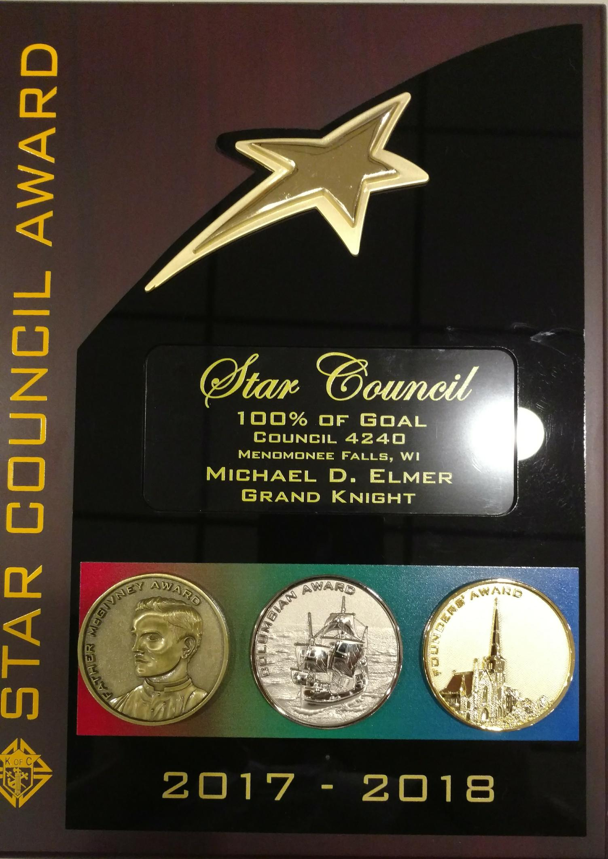

Congratulation brother Knights on achieving the Star Council award! It was been 33 years since we last achieved this milestone. Thank you to all our brothers that helped us accomplish this feat!


2019 Men’s Conference
Be Bold and Courageous

A Catholic conference for men of all ages.

“Be strong and steadfast; have no fear or dread of them, for it is the LORD, your God, who marches with you; he will never fail you or forsake you.” – Deuteronomy 31:6

Reconnect with God – this day will change your life.
We start and end with Christ! Optional Mass at 7:00 A.M. Closing Mass at 4:00 P.M. with Archbishop Listecki.
Fathers, bring your sons! Age-appropriate sessions for boys 8th grade and below, as well as high-school age young men.
Wives and daughters, support your men throughout the day in Adoration.
More than 100 priests will hear confessions throughout the day.
Build a special bond with a powerful Father/Son blessing — a conference favorite.

Please welcome our speakers:
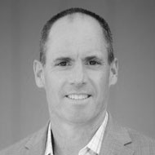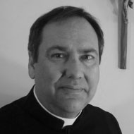
John Abbate Fr. John Zuhlsdorf Michael O’Neill
“Fr. Z” “The Miracle Hunter”

Saturday, March 30, 2019
Miller High Life Theater
(formerly Milwaukee Theater)

CONFERENCE PRICING
EARLY-BIRD THROUGH 24 MARCH:
Individual: $46
Groups 5+: $41
Students: $25
Religious: FREE

Come and recharge your spiritual battery with your brother Knights!
If you are interested in attending, Please contact Brother Mike Elmer at Crazy_e98@hotmail.com or 262-893-5403.

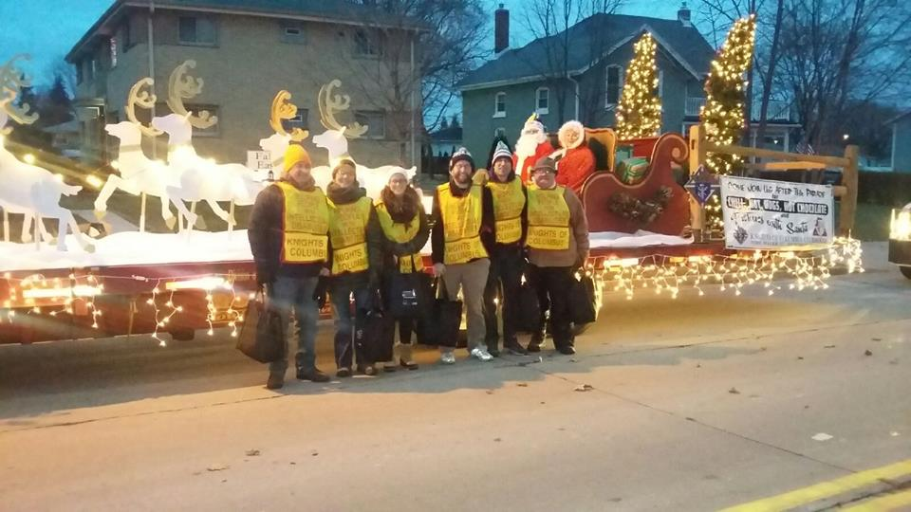
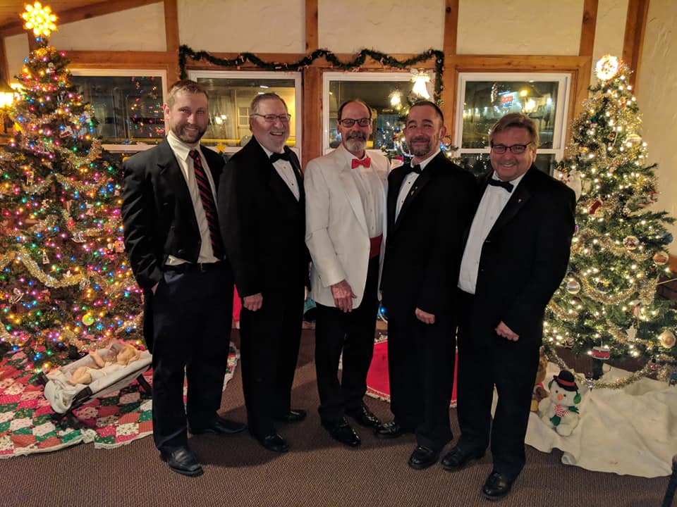

Knights of Columbus
P.O. Box 151
Menomonee Falls, WI 53052-0151
Address Service Requested

Important Dates for January and February:
January 8th: Special Olympics Super Bowl party Meeting – 6:30pm
January 9th : Corporation Meeting - 6:00pm
January 9Th : Officers Meeting - 7:00pm
January 14th: Bingo at Menomonee Falls Care Center – 7:00pm
January 16th: Duck Derby Meeting – 7:00pm
January 23rd : Membership Meeting – 7:00pm*
February 3rd – Special Olympic Super Bowl Party – 12:00pm
February 11th - Bingo at Menomonee Falls Care Center – 7:00pm
February 13th - Corporation Meeting - 6:00pm
February 13^{th -} Officers Meeting - 7:00pm
February 20th – Duck Derby Meeting – 7:00pm
February 27th - Membership Meeting – 7:00pm*

* Rosary begins at 6:30pm before each general membership meeting

